Supplementary material

Table S1: Reaction mix for pre-PCR targeting Pf varATS using KAPA Polymerase performed directly on DBS
Reagent | conc_{stock} | conc_{final} | vol (1rxn)
5x KAPA HiFi Buffer | 5x | 1x | 10 µl
KAPA dNTPs Mix | 10mM | 0.3mM | 1.5 µl
varATS Primer Mix (f/r) | 10µM each | 0.45MµM | 2.5 µl
1U/µl KAPA HiFi HotStart DNA Polymerase |  |  | 1µl
PCR grade H₂O, aliquoted |  |  | 40 µl
Infected DBS punch (3mm) |  |  | 1 punch
Negative DBS punch (3mm) |  |  | 4 punches
Total reaction volume |  |  | 55 µl

Table S2: Cycling Protocol of the pre-PCR targeting Pf varATS using KAPA Polymerase
Temperature | Time | Cycles
95°C | 3 minutes | 1x
98°C | 20 seconds | 10x
55°C | 15 seconds
72°C | 30 seconds
72°C | 1 minutes | 1x

Table S3: Reaction mix for pre-PCR targeting Pf varATS using Hemo KlenTaq Polymerase performed directly on DBS
Reagent | conc_{stock} | conc_{final} | vol (1rxn)
5x Hemo KlenTaq Reaction Buffer | 5x | 1x | 10 µl
dNTPs | 2mM | 0.3mM | 5 µl
varATS Primer Mix (f/r) | 10µM each | 0.45MµM | 2.5 µl
Hemo KlenTaq Polymerase |  |  | 4µl
PCR grade H₂O, aliquoted |  |  | 33.5 µl
Infected DBS punch (3mm) |  |  | 1 punch
Negative DBS punch (3mm) |  |  | 4 punches
Total reaction volume |  |  | 55 µl

Table S4: Cycling Protocol of the pre-PCR targeting Pf varATS using Hemo KlenTaq Polymerase
Temperature | Time | Cycles
95°C | 3 minutes | 1x
95°C | 20 seconds | 10x
55°C | 30 seconds
68°C | 1 minutes
68°C | 10 minutes | 1x

Table S5: Reaction mix for pre-PCR targeting Pf varATS using MyTaq Polymerase performed directly on DBS
Reagent | conc_{stock} | conc_{final} | vol (1rxn)
MyTaq Blood-PCR Mix, 2x | 2x | 1x | 25 µl
varATS Primer Mix (f/r) | 10µM each | 0.45MµM | 2.5 µl
PCR grade H₂O, aliquoted |  |  | 27.5 µl
Infected DBS punch (3mm) |  |  | 1 punch
Negative DBS punch (3mm) |  |  | 4 punches
Total reaction volume |  |  | 55 µl

Table S6: Cycling Protocol of the pre-PCR targeting Pf varATS using MyTaq Polymerase
Temperature | Time | Cycles
95°C | 3 minutes | 1x
95°C | 15 seconds | 10x
55°C | 30 seconds
72°C | 45 seconds

The performance in direct pre-PCR of Phusion Blood Direct polymerase (Thermo Fisher Scientific) was compared to that of other polymerases using a dilution row of malaria positive (3D7) whole blood equivalent of 3µl per sample (1x3mm punch). Kapa HotStart polymerase (Kapa Biosystems) is a high fidelity polymerase with the advantage of a lower cost compared to Phusion polymerase. Kapa polymerase reached a similar sensitivity, but showed greater variations between replicates compared to Phusion polymerase. Hemo KlenTaq polymerase showed a low sensitivity, detecting only parasitaemias of 0.5 parasites/µl and above. MyTaq Blood polymerase (Bioline) reached a sensitivity similar to Phusion polymerase; however, at the time tested it was more expensive compared to Phusion polymerase. Thus, Phusion polymerase was selected for further validation and comparison to extraction methods.

Table S7: Sensitivity of parasite detection achieved by the optimized direct pre-PCR protocol using Phusion polymerase and varATS qPCR. For this experiment a malaria positive whole blood equivalent of 3µl per sample (1x3mm punch) and a malaria negative whole blood equivalent of 12µl (4x3mm punches) were used.
Parasite/µl | Cт 1 | Cт 2 | Cт 3 | Cт 4 | Cт Mean | Cт StDev
10⁴ | 17.98 | 18.21 | Not done |  | 18.10 | 0.12
10³ | 24.95 | 20.61 |  |  | 22.78 | 2.17
10² | 23.96 | 24.20 |  |  | 24.08 | 0.12
10¹ | 27.25 | 30.23 |  |  | 28.74 | 1.49
1 | 29.84 | 33.85 | 31.06 | 30.44 | 31.30 | 1.54
0.50 | Undetermined | 30.66 | 29.95 | 28.93 | 29.85 | 0.71
0.10 | Undetermined | Undetermined | 32.47 | Undetermined | 32.47 | 0.00
0.05 | Undetermined | 31.01 | 31.07 | Undetermined | 31.04 | 0.03

Table S8: Sensitivity of parasite detection achieved by the optimized direct pre-PCR protocol using Kapa polymerase and varATS qPCR. For this experiment a malaria positive whole blood equivalent of 3µl per sample (1x3mm punch) and a malaria negative whole blood equivalent of 12µl (4x3mm punches) were used.
Parasite/µl | Cт 1 | Cт 2 | Cт 3 | Cт 4 | Cт Mean | Cт StDev
104 | 17.02 | 17.26 | Not done |  | 17.14 | 0.12
103 | 20.57 | 20.78 |  |  | 20.68 | 0.10
102 | 23.73 | 23.91 |  |  | 23.82 | 0.09
101 | 27.76 | 27.86 |  |  | 27.81 | 0.05
1 | 32.18 | 33.02 | 32.10 | 32.35 | 32.42 | 0.36
0.50 | 35.21 | 32.39 | Undetermined | 31.33 | 32.98 | 1.64
0.10 | Undetermined | 37.03 | 31.72 | Undetermined | 34.38 | 2.65
0.05 | Undetermined | Undetermined | Undetermined | 35.89 | 35.89 | 0.00

Table S9: Sensitivity of parasite detection achieved by the optimized direct pre-PCR protocol using Hemo KlenTaq polymerase and varATS qPCR. For this experiment a malaria positive whole blood equivalent of 3µl per sample (1x3mm punch) and a malaria negative whole blood equivalent of 12µl (4x3mm punches) were used.
Parasite/µl | Cт 1 | Cт 2 | Cт 3 | Cт 4 | Cт Mean | Cт StDev
10⁴ | 17.78 | 17.17 | Note done |  | 17.48 | 0.30
10³ | 20.94 | 22.69 |  |  | 21.81 | 0.87
10² | 22.61 | 22.32 |  |  | 22.46 | 0.14
10¹ | 27.54 | 27.27 |  |  | 27.40 | 0.14
1 | 32.31 | Undetermined | Undetermined | 39.35 | 35.83 | 3.52
0.50 | Undetermined | 32.31 | Undetermined | Undetermined | 32.31 | 0.00
0.10 | Undetermined | Undetermined | Undetermined | Undetermined | Undet. | Undet.
0.05 | Undetermined | Undetermined | Undetermined | Undetermined | Undet. | Undet.

Table S10: Sensitivity of parasite detection achieved by the optimized direct pre-PCR protocol using MyTaq polymerase and varATS qPCR. For this experiment a malaria positive whole blood equivalent of 3µl per sample (1x3mm punch) and a malaria negative whole blood equivalent of 12µl (4x3mm punches) were used.
Parasite/µl | Cт 1 | Cт 2 | Cт 3 | Cт 4 | Cт Mean | Cт StDev
10⁴ | 18.23 | 18.72 | Note done |  | 18.47 | 0.24
10³ | 21.76 | 22.29 |  |  | 22.03 | 0.26
10² | 24.82 | 25.50 |  |  | 25.16 | 0.34
10¹ | 28.87 | 27.84 |  |  | 28.35 | 0.51
1 | 33.73 | 29.28 | 31.87 | 32.01 | 31.72 | 1.59
0.50 | 31.04 | 33.01 | 30.42 | 30.57 | 31.26 | 1.04
0.10 | Undetermined | 36.07 | Undetermined | Undetermined | 36.07 | 0.00
0.05 | 36.36 | 34.12 | Undetermined | 32.58 | 34.35 | 1.55

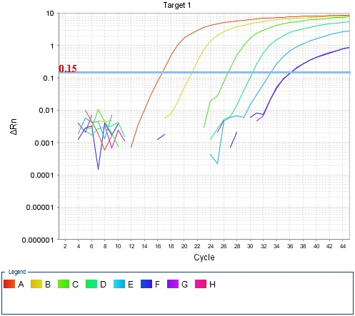
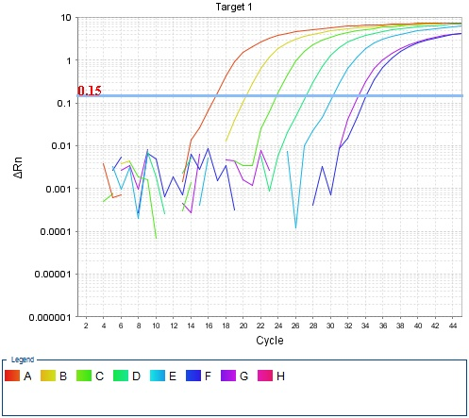
Figure S1: varATS qPCR amplification of 10-fold dilution row of the international WHO DNA standard for Pf without a parasite-negative blood punch added to pre-PCR. Table below graph shows y-intercept, R², and efficiency of the corresponding standard row.
Figure S2: varATS qPCR amplification of 10-fold dilution row of the international WHO DNA standard for Pf with a parasite-negative blood punch added to pre-PCR. Table below graph shows y-intercept, R², and efficiency of the corresponding standard row.
Y-intercept | R² | Efficiency
32.56 | 0.998 | 100.14%

Y-intercept | R² | Efficiency
35.56 | 0.958 | 82.77%

