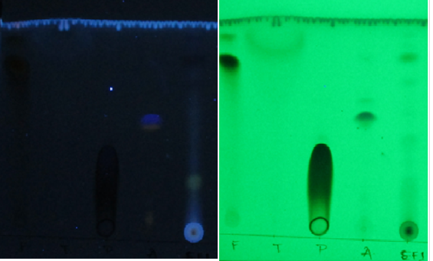
TLC image at 366 nm
Solvent front
0.96
0.91
0.88

0.74

0.57

0.45

Origin spot (Crude extract EF1)
TLC image at 254 nm

S10: TLC of Curvularia aeria MTCC- 12847 viewed under 254 nm and 366 nm along with standards F: Flavonoid standard (Quercetin), T: Terpenoids standard (linalool), P: Phenol standard, A: Alkaloids standard (Atropine), EF1: Ethyl acetate crude extact, (In the solvent system of Chloroform: Methanol: Ethyl acetate =9:3:5)

