Biocontrol of tomato bacterial wilt by a new strain Bacillus velezensis FJAT-46737 and its lipopeptides
Meichun Chen, ^{1#} Jieping Wang, ^{1#} Bo Liu, ^{1*} Yujing Zhu, ^{1*} Rongfeng Xiao¹, Wenjing Yang, ² Cibin Ge ¹ and Zheng Chen ¹
¹Agricultural Bioresources Research Institute, Fujian Academy of Agricultural Sciences, Fuzhou, 350003, China
²College of Biological Science and Engineering, Fuzhou University, Fuzhou, 350001, China
# The authors contribute equally in this work.
* Corresponding authors: Tel/Fax: +86059187864601. E-mail: fzliubo@163.com (Bo Liu); zyjingfz@163.com (Yu-Jing Zhu)

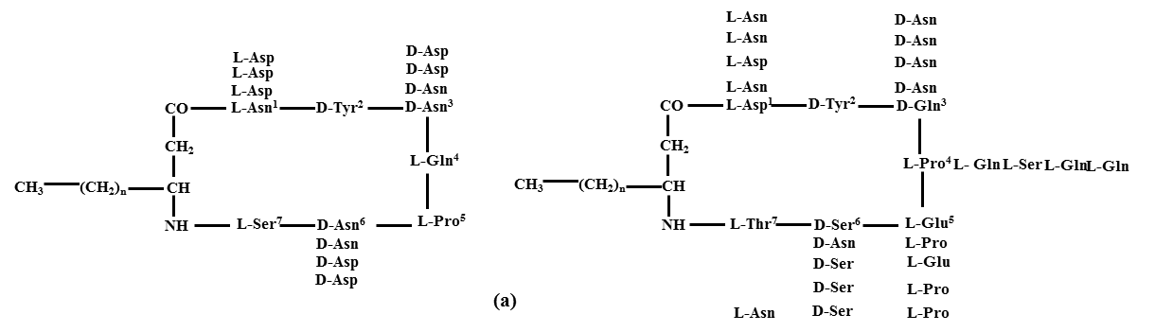
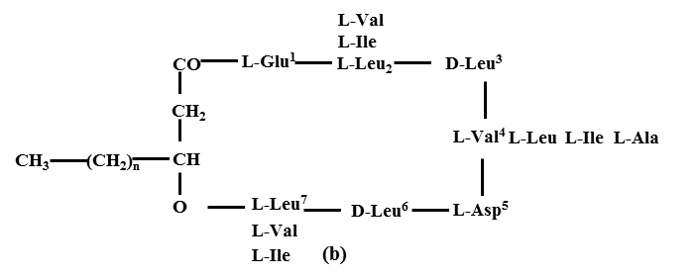
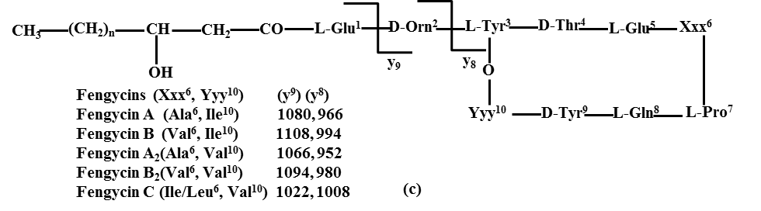
Figure S1. The chemical structure of three types of cyclic lipopeptides.

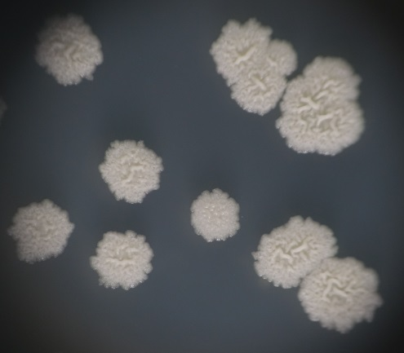
Figure S2. Morphology of Bacillus strain FJAT-46737

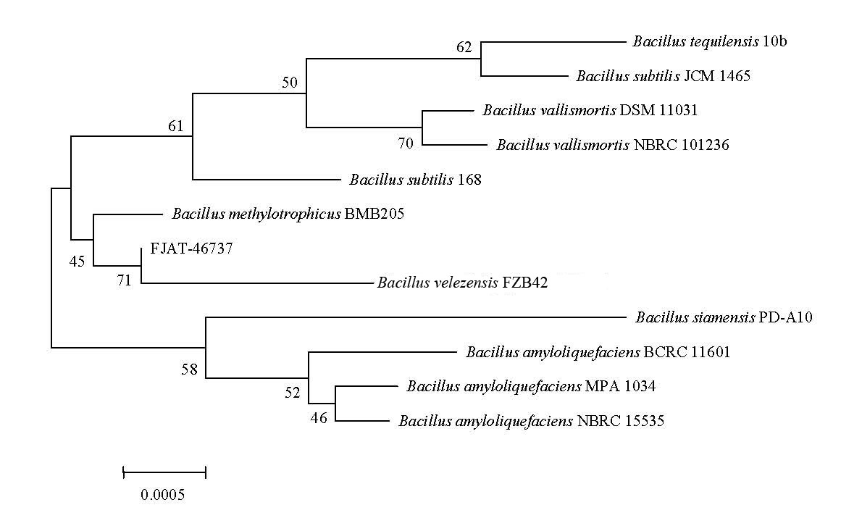
Figure S3. Phylogenetic tree based on the 16S rDNA sequences showing the position of strain FJAT-46737 (accession number: MG924092). The type strains of Bacillus sp. and representatives of some other related taxa. Scale bar represents 0.001 substitutions per nucleotide position. It is note that the strain B. amyloliquefaciens subsp. plantarum FZB42 was renamed as B. velezensis.
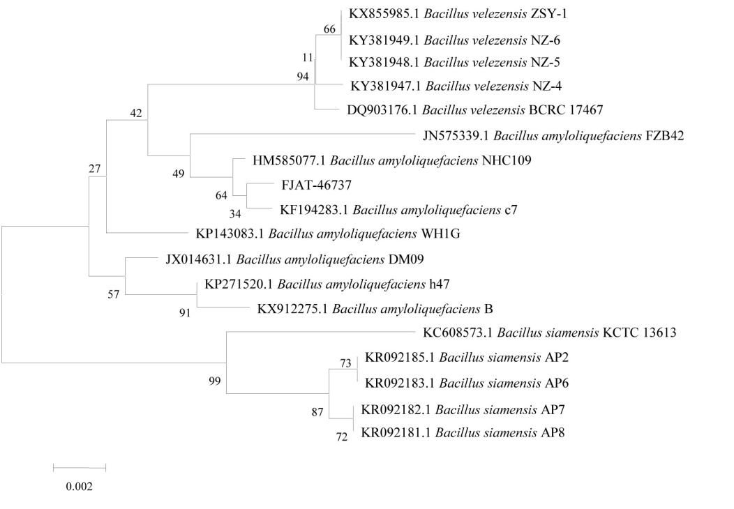
Figure S4. Phylogenetic tree based on the gyrB sequences showing the position of strain FJAT-46737 (accession number: MH470338). The type strains of Bacillus sp. and representatives of some other related taxa. Scale bar represents 0.001 substitutions per nucleotide position

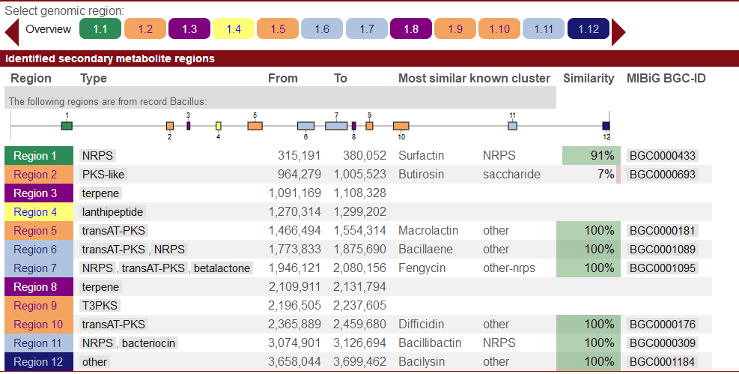
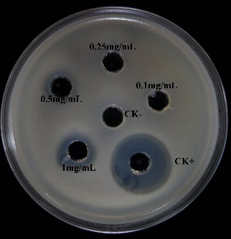
Figure S5. The prediction of gene clusters of bioactive secondary metabolites in strain FJAT-46737

Figure S6. The antibacterial photo of lipopeptide (0.1~1mg/mL) against R. solanacearum FJAT-91
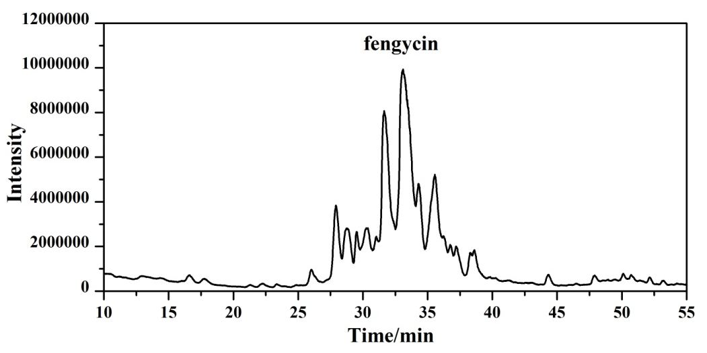
Figure S7. The full scan LC–ESI–MS chromatogram of fraction SPE70.

Table S1. Culture medium components
No. | medium | culture medium components (g/L)
1 | A medium (LB) | tryptone 10, yeast extracts 5, NaCl 5
2 | B medium (NA) | beef Extract 3, peptone 5, glucose 10
3 | C medium | beef Extract 5, peptone 10, yeast extracts 5, NaCl 5, glucose 10
4 | D medium | beef Extract 5, peptone 10, yeast extracts 5, glucose 10
5 | E medium | Potato extract 5 peptone 10, NaCl 5, glucose 15
6 | F medium | beef Extract 8, yeast extracts 5, glucose 1
7 | PDA medium | potato, 200, glucose, 20, agar, 18

